This source code is licensed, not sold, and is subject to a written license agreement. Among other things, no portion of this source code may be copied, transmitted, disclosed, displayed, distributed, translated, used as the basis for a derivative work, or used, in whole or in part, for any program or purpose other than its intended use in compliance with the license agreement as part of the QualNet software. This source code and certain of the algorithms contained within it are confidential trade secrets of Scalable Network Technologies, Inc. and may not be used as the basis for any other software, hardware, product or service.

SCENARIO PURPOSE: Illustrate implementing Routing Failover on High Speed and Low Speed Links with EIGRP and resulting Packet Loss.

SCENARIO:

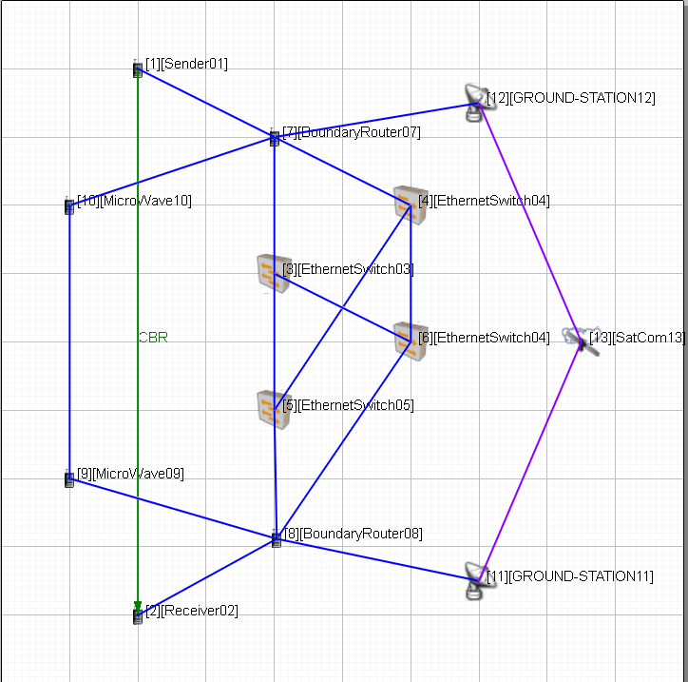

There are four Ethernet Switches that form a fully meshed wired network backbone. These Ethernet Switches are dual homed to boundary router. The boundary routers also link to a Microwave Network at 1.54 Mbps and a STACOM network at 128 Kbps. Data is sent from Node 1/Sender to Node 2/Receiver with EIGRP routing determining the network path used. Starting with the Interface Faults at Node 7 interfaces 3 and 4, the application traffic is redirected to the Microwave link, then the SATCOM link based on EIGRP decisions regarding link and bandwidth availability.

The Interface faults on Node 7 are as follows:

INTERFACE-FAULT 190.0.9.2 40M 60M

INTERFACE-FAULT 190.0.3.1 20M 70M

INTERFACE-FAULT 190.0.3.7 20M 70M

This forces traffic from the Ethernet Network to the Microwave then back to the Ethernet as the faults clear at 70 minutes and the scenario has an 80 minute simulation time. The traffic Rate of 1.6Mbps exceeds the link capacity for both the Microwave and SATCOM links resulting in packet loss while those respective Network Patch are in use.

APPLICATIONS:

Node 1 is sending CBR data packets to Node 2 with .005 Second Intervals at 1.6Mbps

DESCRIPTION OF THE FILES:

1. GroundMicroSatFailover-EIGRP.app - QualNet configuration file for application input.
2. GroundMicroSatFailover-EIGRP.config - QualNet configuration input file.
3. GroundMicroSatFailover-EIGRP.expected.stat - QualNet statistics collection.
4. GroundMicroSatFailover-EIGRP.nodes - QualNet configuration file for node position.
5. GroundMicroSatFailover-EIGRP.fault - QualNet fault configuration file.
6. GroundMicroSatFailover-EIGRP.display - QualNet visualization parameters.
7. groundsat.png – SATCOM node ICON.
8. satdish.3ds – 3d Satellite ICON.
9. GroundMicroSatFailover-EIGRP README.docx – This File source.
10. GroundMicroSatFailover-EIGRP README.pdf – This file distributable.